**Knowledge check: Making charts**

1. Create a new spreadsheet by clicking ‘+’.
2. Name the spreadsheet by clicking in ‘Untitled spreadsheet’. This highlights it; then you can rename it.
3. Choose some data from your bug hunt and enter it into the spreadsheet:
   1. Type the fields as column headings.
   2. Then type the data into the rows.

1. Now you are going to put this data into a chart.
   1. Left-click to highlight the data for the chart.
   2. Click ‘Insert’ and then ‘Chart’.

**Key takeaways**

1. You will be **data** detectives by organising things into groups and answering questions about them.
2. You will collect data using tick or **tally charts**.
3. You will take, edit and improve photographs.
4. You will record the information on a digital map.
5. Finally, you will become a teacher and use a presentation to share what you have learned.

**5 words to remember**

**binary:** a number system that uses only two numbers: 0 and 1; computers work in binary

**branching database:** helps you to ask questions one by one to find out what something is

**classification key:** series of questions; ‘yes’ goes one way and ‘no’ goes the other way

**data:** structured information gathered for analysis, often, but not always, as numbers

**database:** neatly organised collection of information on a computer

**tally chart:** used to record data quickly; you record lines in groups of five

Pla

**Knowledge check: Classification keys**

We will be using a **classification key** to identify invertebrates. This one is **binary** and uses ‘yes’ / ‘no’ answers. It can be used as a **branching database**.

Look at the pictures of invertebrates that you might see on your bug hunt.

Use the classification key to identify the bugs.

**Knowledge check: Using onion-skinning**

On My Maps you can zoom in or out and add pins to the map.

1. Zoom in to see a particular location.
2. Select the ‘pin’ tool and click on the location.
3. Write a title and caption for the location linked to your bug hunt.

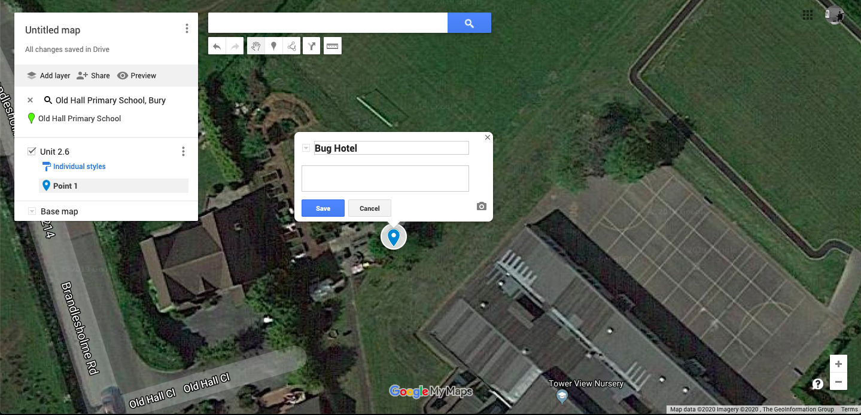

1

2