English
Literacy Tree –‘Leon & The Place Between’ and ‘Zoo’
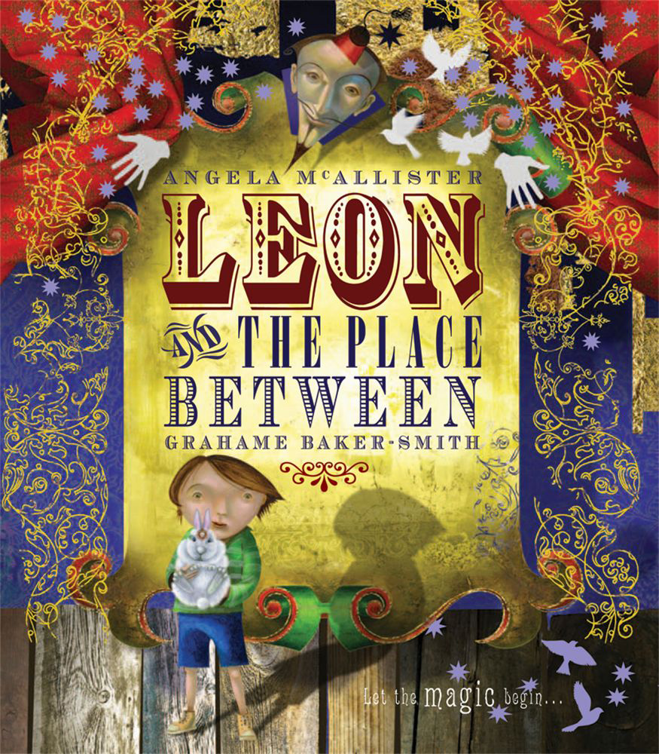
- To use a range of sentence types for persuasion.
- To be able to identify and classify word classes.
- To write a review of a circus performance.
- To use adverbs and adverbials to describe when, where and how.
- To write a descriptive passage.
- To plan the main events of a story.
- To write the opening, middle and end of a story using the structure of a known story.
- To edit and publish independent writing.

Year 4 - Spring 1 

Spanish
- The term we are learning our colours and the names of animals in Spanish.
- We will also explore how to use singular and plural vocabulary in Spanish.
Topic – Local Area and History
- Know how to locate and label countries in the United Kingdom and their surrounding seas.
- Observe and describe how London landmarks have changed over time.
- Undertake a group research project on a London landmark and present findings to the class.
- To research and record facts about Mckenzie Hall.

Maths – White Rose
Length and Perimeter
- To recognise equivalent lengths between m and cm.To recognise equivalent lengths between mm and cm.
- Adding and subtracting different lengths.
- Learning how to measure perimeter – perimeter of rectangles and rectilinear shapes.
Multiplication and Division
- Multiply 3 numbers
- Factor pairs
- Efficient multiplication
- Written methods
- Multiply 2-digits by 1-digit
- Divide 2-digits by 1-digit
- Divide 3-digits by 1-digit.
R.E – What makes me the person I am?
- To apply religious ideas thoughtfully.
- To be able to connect ideas between different religions.
- To suggest meanings behind religious stories with evidence.
- To research St Francis and understand how becoming a Christian changed his life.
- To discover what different religions teach about social action and community.
Science: Animals including Humans
- Describe the simple functions of the basic parts of the digestive system in humans
- Identify the different types of teeth in humans and their simple functions
- Construct and interpret a variety of food chains, identifying producers, predators and prey.

P.E

- Developing skills in a variety of mixed sport activities.

